**DATA COLLECTION**

1. Collect images of different food items and put it into different subdirectories based on their respective names as shown in the project structure.
2. Create different folders for each of the food items that needs to be recognized.
3. Here, we have five different types of food items namely,

* Apple
* Banana
* Orange
* Pineapple
* Watermelon

And these are saved in their respective subdirectories with their respective names

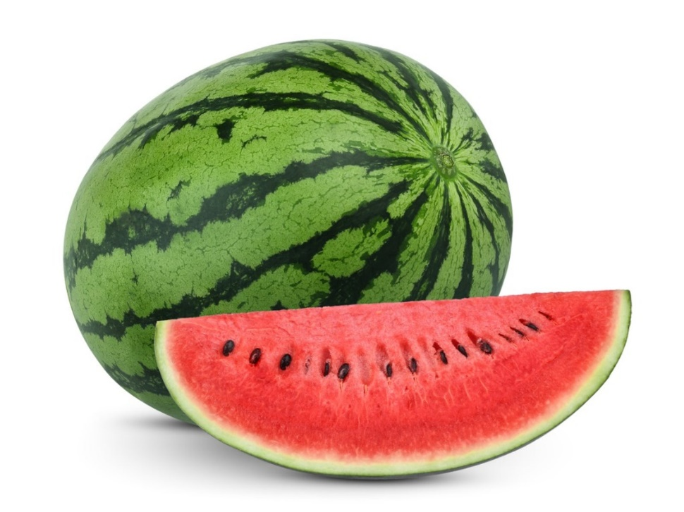

DATA SET LINK